Project Design Phase-II
Data Flow Diagram & User Stories

Date | 31 January 2025
Team ID
Project Name | DarshanEase
Maximum Marks | 4 Marks

Data Flow Diagrams:
The Data Flow Diagram illustrates how users interact with the DarshanEase system to register, log in, view temples, book darshan slots, and make donations. The system processes these requests and stores the data in the database.
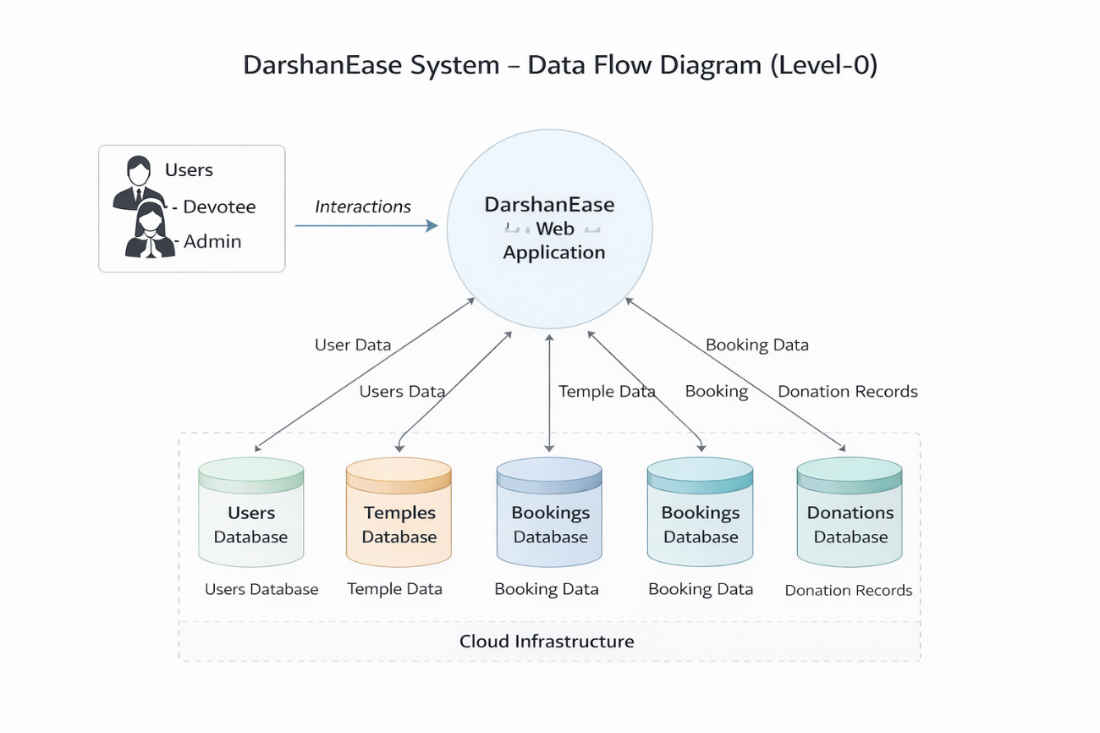

User Stories

User Type | Functional Requirement (Epic) | User Story Number | User Story / Task | Acceptance criteria | Priority
Devotee | Registration | USN-1 | As a user, I can sign up with my email and phone. | I can log in immediately after signing up. | High
Devotee | Booking | USN-2 | As a user, I can choose a specific time slot for darshan. | The system shows "Full" if no spots are left. | High
Devotee | AI Assistant | USN-3 | As a user, I can ask the AI about the history of a temple. | The Gemini AI provides accurate historical facts. | Medium
Devotee | Cancellation | USN-4 | As a user, I can cancel my ticket if my plans change. | My spot is automatically given back to the temple. | High
Organizer | Management | USN-5 | As an organizer, I can add new darshan timings for my temple. | The new slots appear on the user's search list. | High
Organizer | AI Tools | USN-6 | As an organizer, I want the AI to write a description for my temple. | Gemini generates a professional description. | Low
Admin | Donations | USN-7 | As an admin, I can see a list of all donations made today. | I can see the total money collected in one view. | High
Admin | User Control | USN-8 | As an admin, I can change a regular user into an Organizer. | The user gets access to the "Manage Temple" page. | Medium

